PRACTICAL FILE

Class XII - Computer Science with Python(083)

Suggested Practical list

**Term-1**

**Python Programming**

● Read a text file line by line and display each word separated by#.

● Read a text file and display the number of vowels /consonants /uppercase/ lowercase characters in the file.

● Remove all the lines that contain the character 'a' in a file and write it to another file.

● Create a binary file with name and roll number. Search for a given roll number and display the name, if not found display appropriate message.

● Create a binary file with roll number, name and marks. Input a roll number and update the marks.

● Write a random number generator that generates random numbers between 1 and 6 (simulates a dice).

● Create a CSV file by entering user-id and password, read and search the password for given user id.

## Program 1: Write a program to read and display file content line by line with each word separated by #.

## 

## OUTPUT

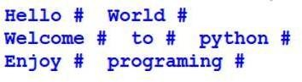

Program: 2 Read a text file and display the number of vowels in the file.

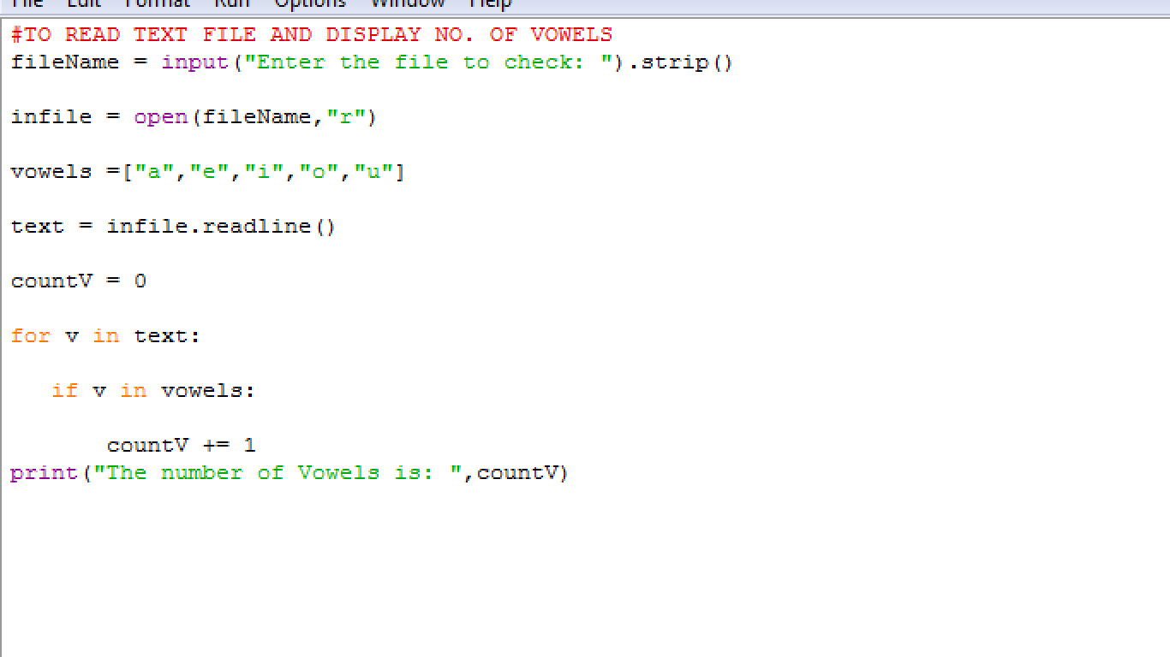

OUT PUT: 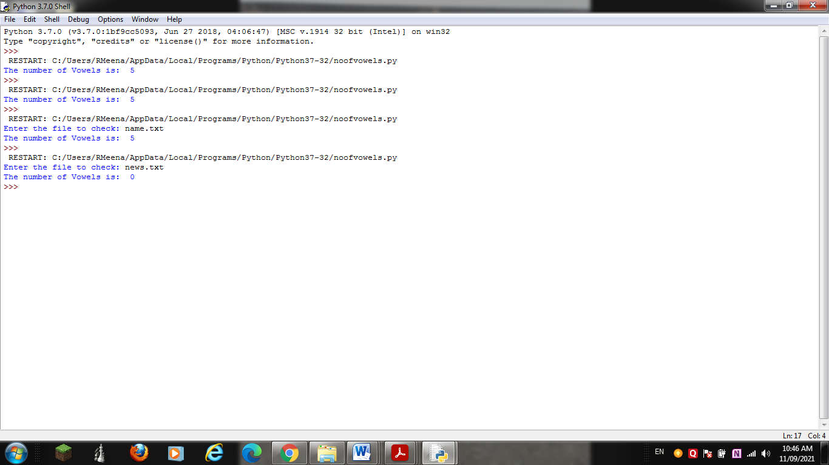

Program: 3 Read a text file and display the number of consonants in the file.

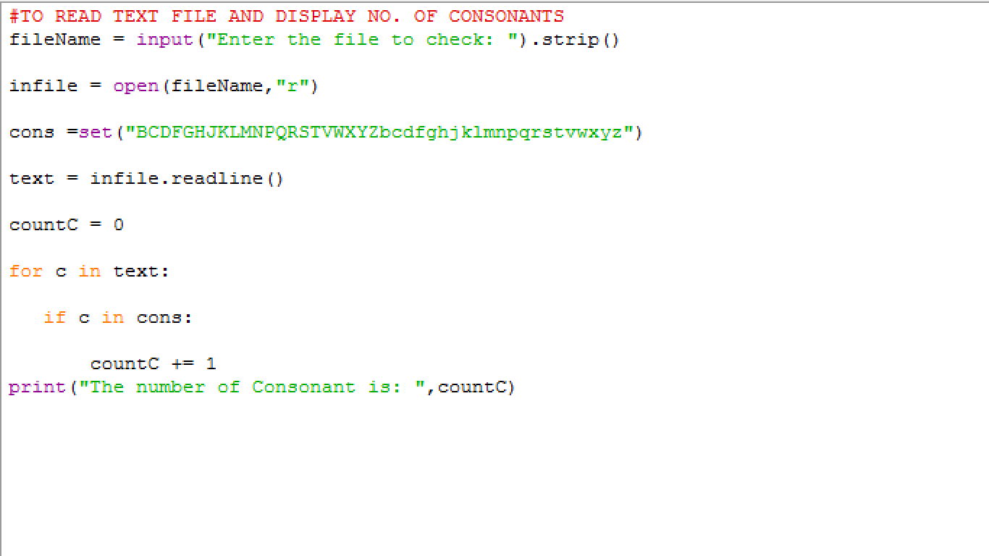

OUTPUT

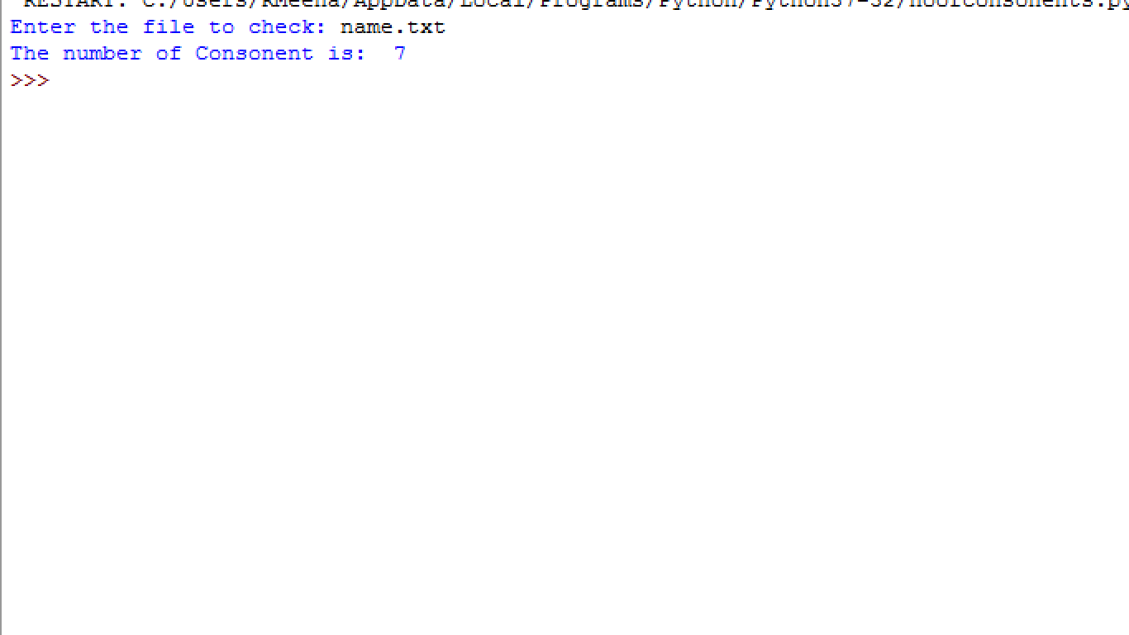

Program 4: Read a text file and display the number of lowercase letters in the file.

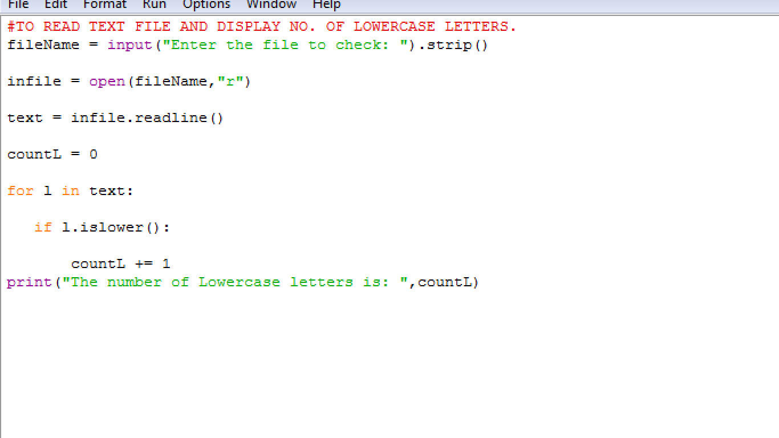

OUTPUT

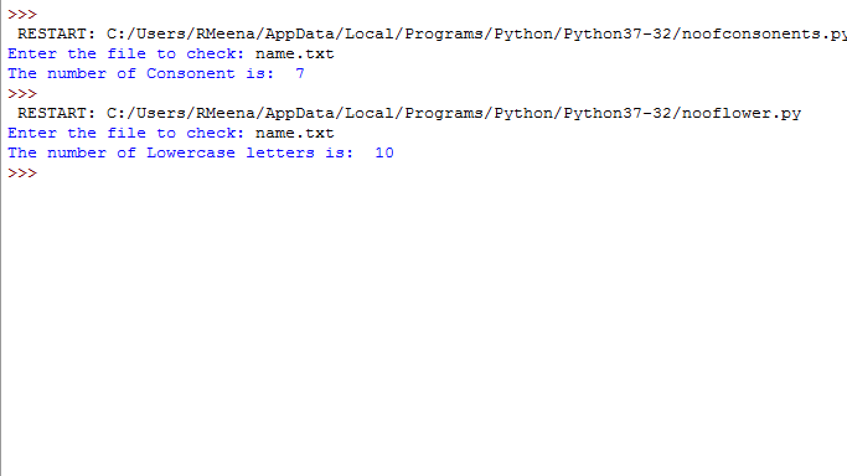

Program 5: Read a text file and display the number of uppercase letters in the file.

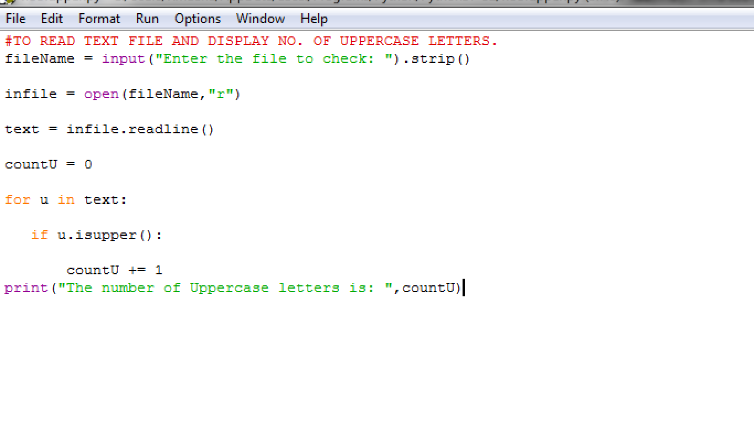

OUTPUT

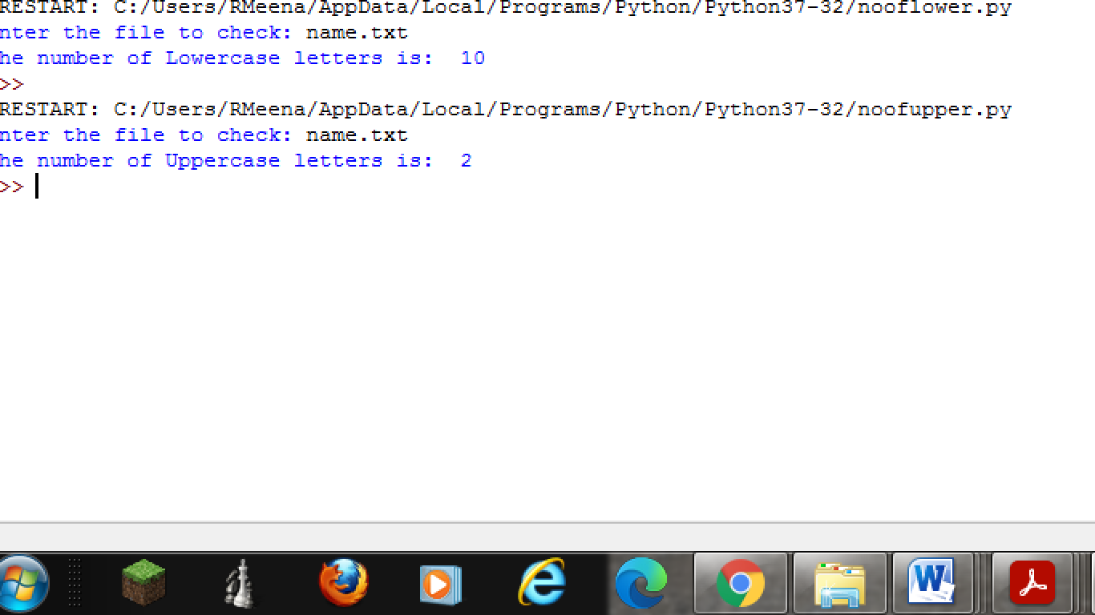

PROGRAM -6: Remove all the lines that contain the character 'a' in a file and write it to another file.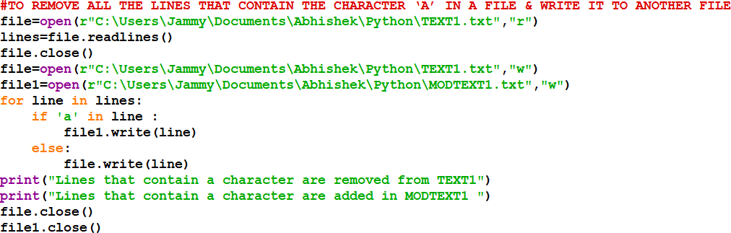

OUTPUT

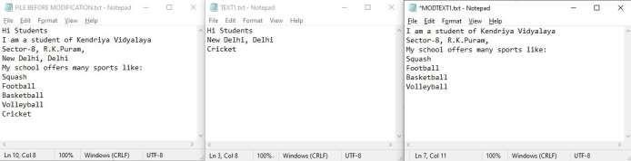

## Program 7: Write a Program to read data from data file in append mode and use write Lines function utility in python.

## 

OUTPUT:

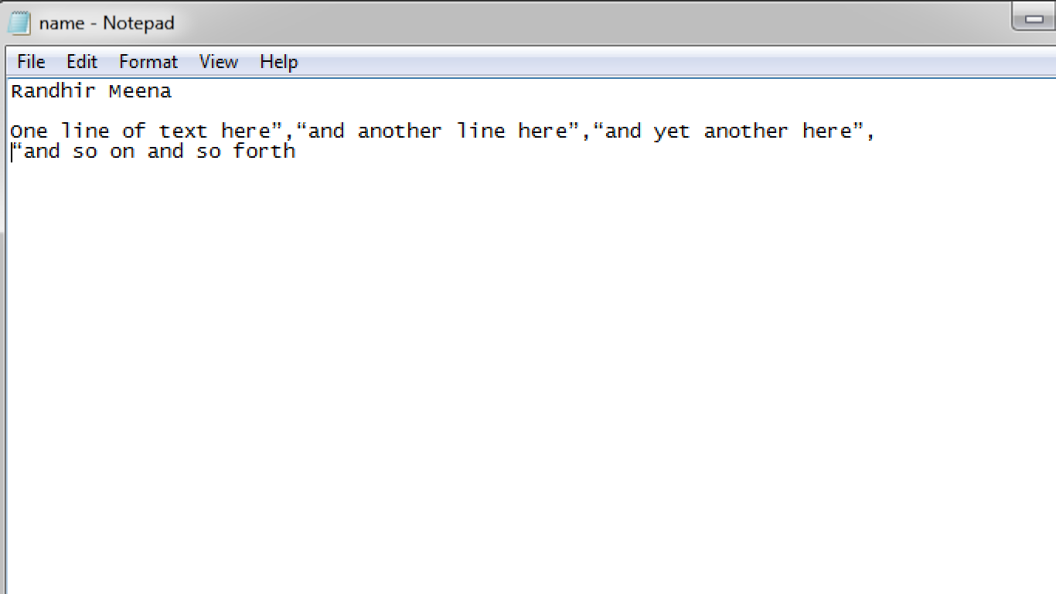

PROGRAM 8: Create a binary file with name and roll number. Search for a given roll number and display the name, if not found display appropriate message.

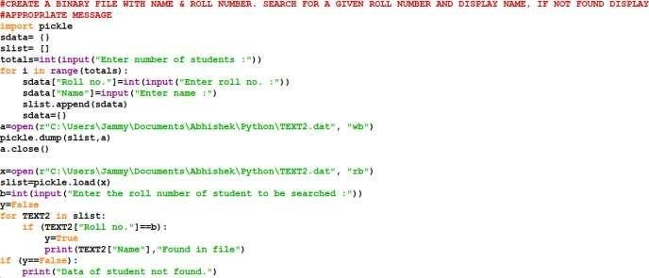

OUTPUT

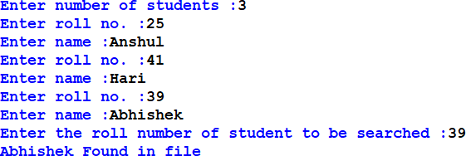

PROGRAM 9: Create a binary file with roll number, name and marks. Input a roll number and update the marks.

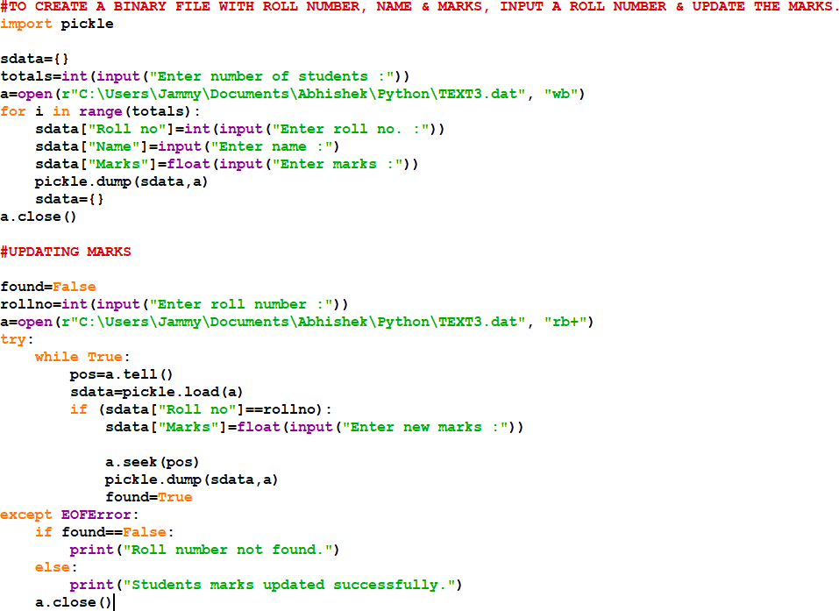

OUTPUT

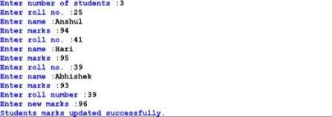

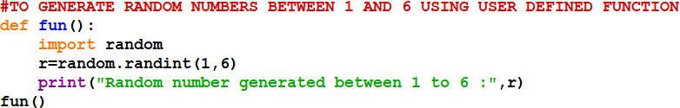PROGRAM 10: Write a random number generator that generates random numbers between 1 and 6 using user defined function (simulates a dice).

OUTPUT



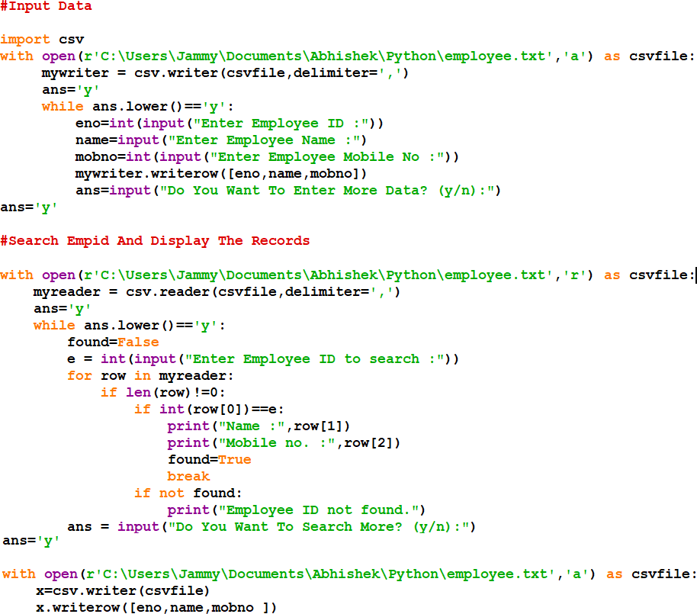PROGRAM-11: Write a program to create a CSV file with empid, name and mobile no. and search empid, update the record and display the records.

OUTPUT:

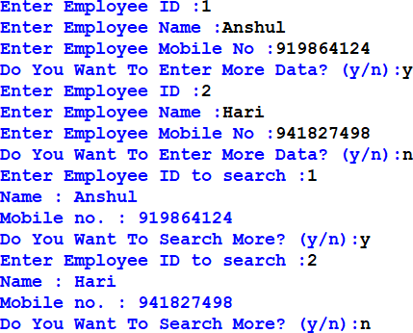

PROGRAM-12: Program to enter two numbers and print the arithmetic operations like +,-,*,/, // and %.

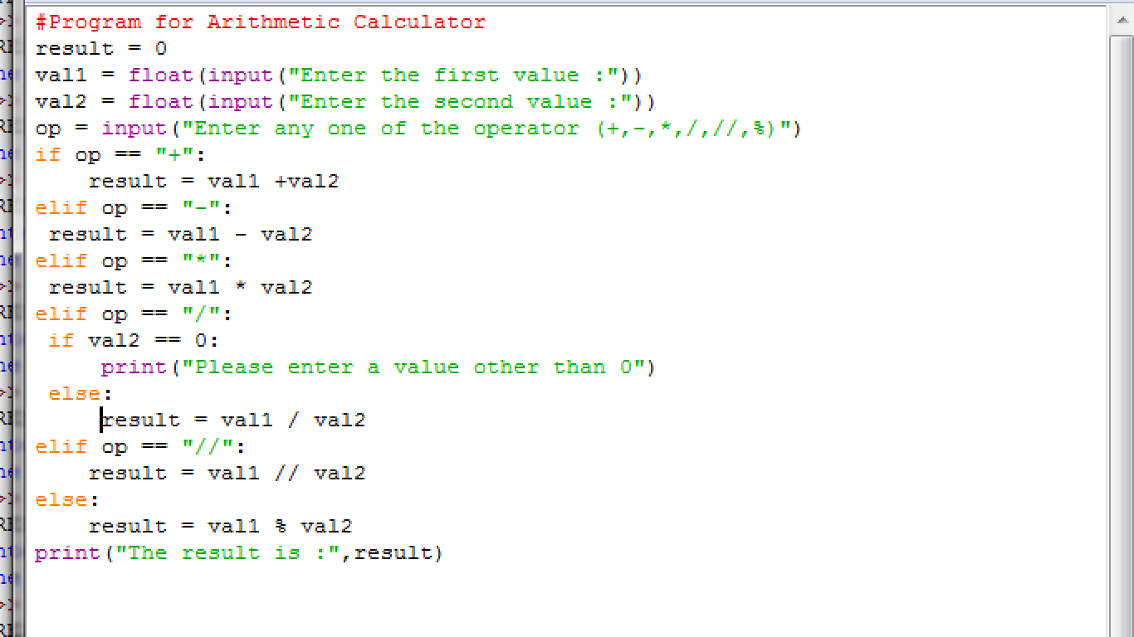

OUTPUT:

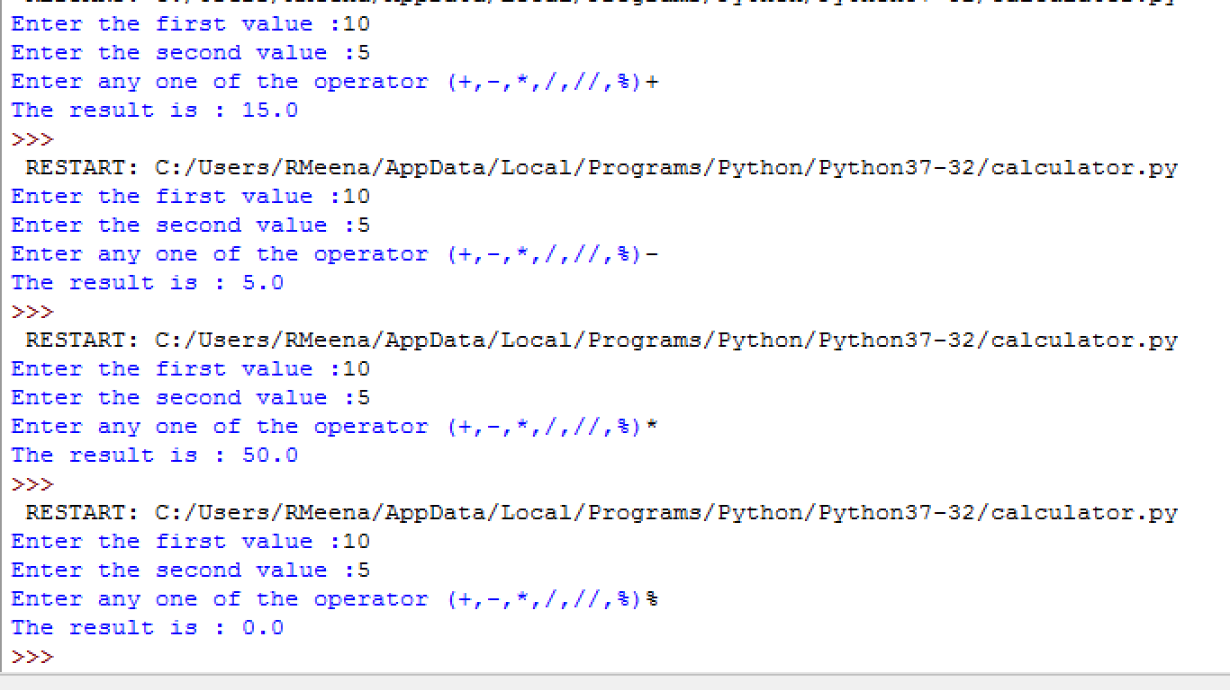

PROGRAM-13: Write a Program to check if the entered number is Armstrong or not.

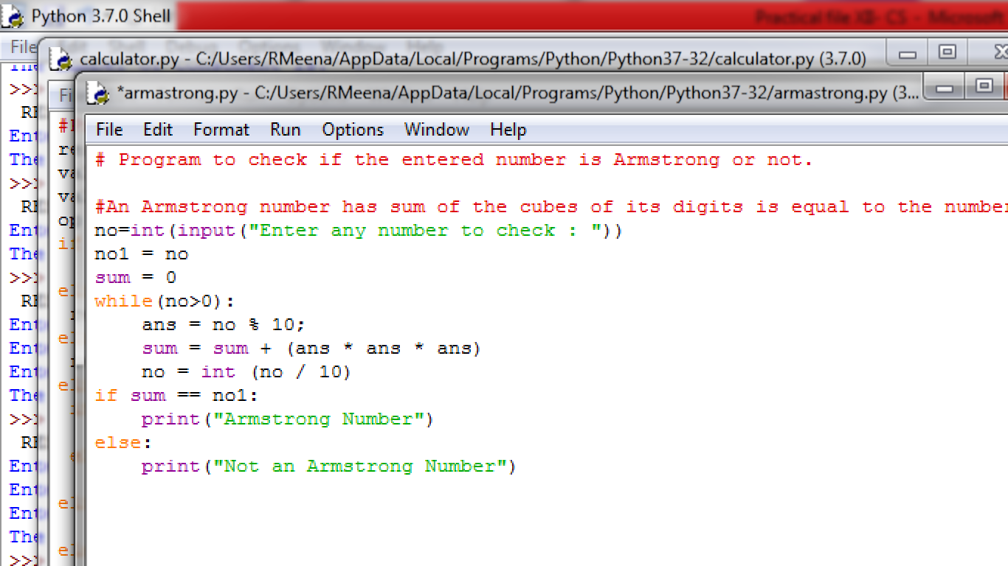

OUTPUT:

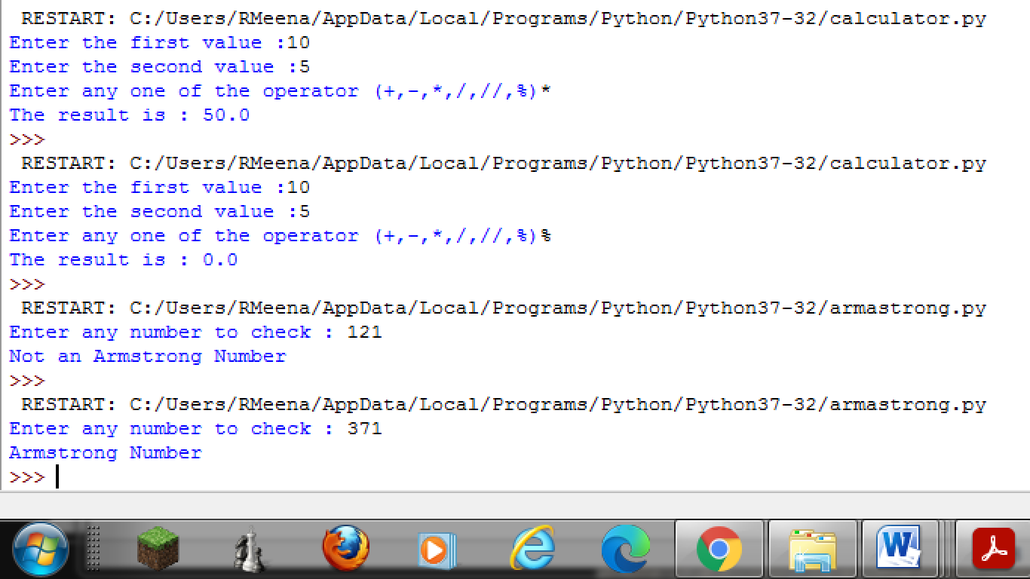

**Program 14: Write a Program to find factorial of the entered number.**

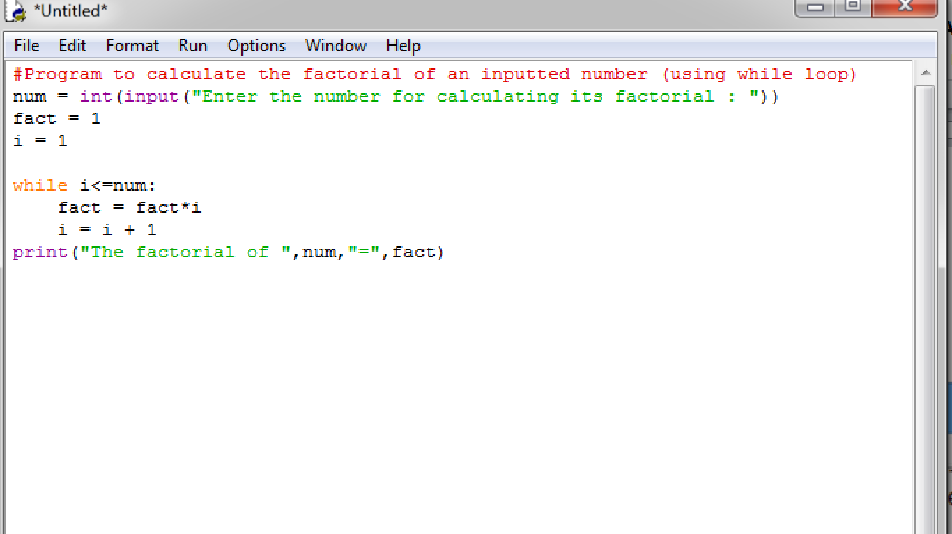

OUTPUT:

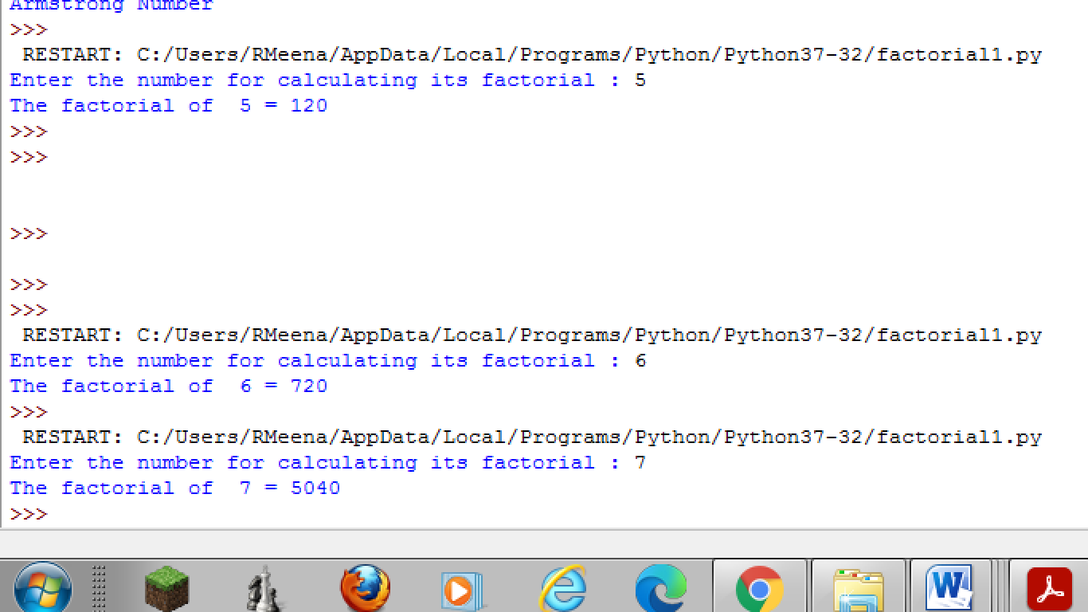

## Program 15: Write a Program to enter the number of terms and to print the Fibonacci Series.

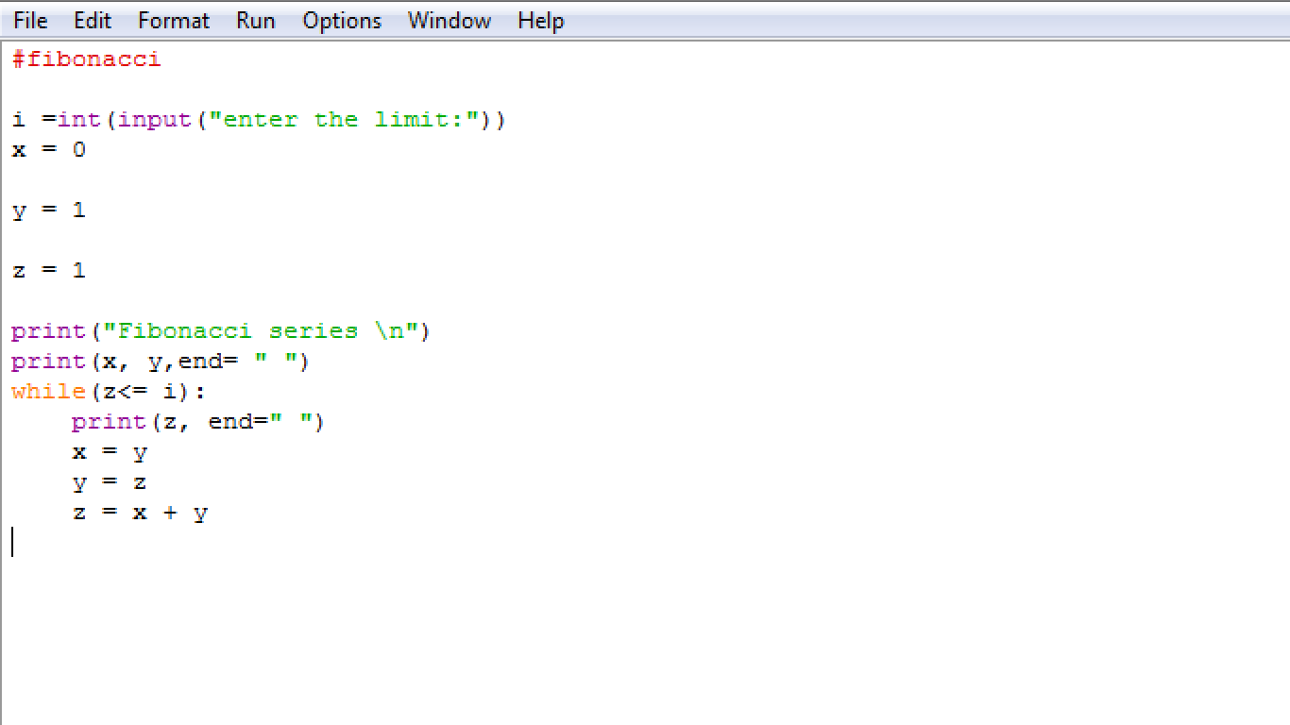

OUTPUT:

